Peyton Bowen

**Formula: Media Variety Score = (Age/Relationship Status/Hours Per Week)**

For my formula on media consumption, I wanted to look into how different relationship statuses affected one's media intake. Before I began my research, I believed single people would spend more time consuming media, but the results, both online and within my study, proved that not true. As it so happens, a questionnaire done by IHeart found "respondents say they watch TV with their partners for various reasons, including 33% stating it "merely gives them something to do, another 28% of respondents in a relationship say they watch TV with their significant others because it's an activity that "doesn't require them to leave the house or spend money" (Lee). One article I found stated, "Thirty-one percent of respondents say they believe they watch more TV when they're in a relationship than when they were single (Lee). Another critical piece of information that helped me create my formula came from a study by the American Enterprise Institution. In a study done by their organization, they concluded that "prime-age adults living with an unmarried partner spend much more time watching television than those living with a spouse" (Roth). Due to this fact, I wanted to break up my participants as single, dating, and also married. I assigned single people as 1, people dating as 2, and married as 3.

Before I dove into statistics of media usage differences between singles and those in relationships, I would have guessed that singles spend more time on social media. A 2019 study by Stacy Jo Dixon at Statista found that those in committed relationships were 48% more likely to use social media to share and communicate about their relationship than singles, at 26%. My original hypothesis about this topic was that singles would be more likely to make it known they are single and seeking partnerships. Those in relationships care more about sharing and showing off their status. According to Enterprise Apps Today, 47% of couples agreed to go through their partner's social media accounts secretly. The reason couples use social media could come from insecurity.

Another factor necessary to include was age. There is this idea that younger age groups spend substantially more time using media, but I do not see that in my day-to-day life. In today's world, almost everyone interacts with media in some way, shape, or form. According to Statista, Social media was the most time-consuming media pastime for age groups 16 to 44, while internet users older than that spent more of their time watching linear TV. Their data also shows that the 25-34 age group statistically spends the most time using media, but the age group 55-64 who placed last in hours per week are only 5.2 hours behind. In my study, I questioned people ranging in age from 23 to 55.

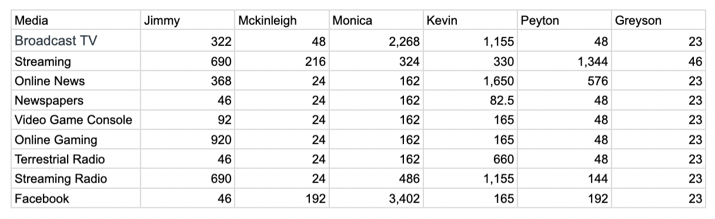

My participants who scored the lowest and logged the least hours were Mckinleigh and Greyson, both single. When questioned, they both answered that the only TV they watch is shows that air once a week or a sporting game with friends. Monica and Kevin are married, and after questioning them, I learned that when married, people share different roles and responsibilities that affect when and which media they consume. Kevin works full time and travels in rental cars for work, often leading to a higher score in sections like radio. In contrast, Monica is a homemaker and does her housework with cable television in the background. The Internal Family Systems group did a similar study and found that "married adults are more likely to have additional responsibilities within the house, so they may engage in family-oriented activities other than watching television." In my study, my married couple shared that when they are together, they try to make the most of their time and seek out date nights rather than consuming media together. My dating participants, Jimmy and myself, logged the most hours on streaming services. I believe not only the relationship status, but also age is a leading factor in this. Young couples who have not married typically have lower-paying jobs and less money to spend on activities together. This aligns with the findings in the Iheart Radio survey I mentioned at the start of my essay.

Based on my findings, the media losers of tomorrow are those in relationships who are not married. In comparison to my test subjects, who are single, they log more hours on almost every media type. The singles tend to spend more time going out in public during their free time. The rising cost of streaming services couples enjoy watching together also factor into them being the "losers of tomorrow." The idea of saving money and staying to watch Netflix might be behind us as these monthly subscriptions are rising to prices comparable to a date night out.

When discussing the losers when looking at the different types of media, it is no surprise that newspapers and local radio came in last with hours per week. This was the result in every test subject, even those who fell into the oldest age category.

Work Cited

Dixon, S. J. (2022, January 28). *U.S. users who used social media to discuss dating life by relationship 2019*. Statista. https://www.statista.com/statistics/1125156/usa-use-social-media-discuss-relationship-status/

Elad, B. (2024, January 30). *Social Media Relationship Statistics 2024 by dating apps, relationships results and dating attitude*. Enterprise Apps Today. https://www.enterpriseappstoday.com/stats/social-media-relationship-statistics.html

Guttmann, A. (2023, February 9). *Media time spent worldwide by age 2022*. Statista. https://www.statista.com/statistics/1365563/media-consumption-time-world-age/

Lee, E. (2021, February 16). *People in relationships watch way more TV than when they were single*. iHeart. https://www.iheart.com/content/2021-02-16-people-in-relationships-watch-way-more-tv-than-when-they-were-single/

Roth, P. (n.d.). *TV-viewing habits and the happiness gap between married and unmarried adults*. Institute for Family Studies. https://ifstudies.org/blog/tv-viewing-habits-and-the-happiness-gap-between-married-and-unmarried-adults

TV-viewing habits and the happiness gap between married and unmarried ... (n.d.). https://www.aei.org/articles/tv-viewing-habits-and-the-happiness-gap-between-married-and-unmarried-adults/